**Mobile Booking**

**Web Service Specification**

Version:3.4

November 8th, 2016

**Revision History**

|  |  |  |
| --- | --- | --- |
| Version | Date | Change Detail |
| 1.0 | 23th July,2015 | Document creation |
| 1.1 | 31th July,2015 | Update section 1.7.2 |
| 2.0 | 6th Aug, 2015 | Combined multiple cites and corporate functions to direct login and late login function |
| 2.1 | 19th Aug, 2015 | Update section 1.7.2  New parameters added |
| 2.2 | 21st Aug, 2015 | Update section 1.7.2 /1.7.3  Parameters revised /Examples added |
| 2.3 | 27th Aug, 2015 | Update section 1.7.2  New passenger types added / Corporate parameters revised |
| 3.0 | 6th Jan,2016 | Update section 1.7.2  Return URL added |
| 3.1 | 30th Jan,2016 | Update section 1.7.2  EBA / SESSIONID added |
| 3.2 | 17th Aug,2016 | Authentication Parameters |
| 3.3 | 29th Aug,2016 | Document Reorganization |
| 3.4 | 8th Nov,2016 | Update section 1.7.2  Channel added |

**Index**

1. Mobile Booking 2

1.1 Purpose 2

1.2 Web Service URLs 2

1.3 Protocol 2

1.4 HTTP Method 2

1.5 Request Header 2

1.6 Query parameters 2

1.7 Request 2

1.7.1 Request XML 2

1.7.2 Field description 3

1.7.3 Request Example 4

1.8 Response 6

1.8.1 Response XML 6

1.8.2 Field Description 6

1.8.3 Response Example 6

1.8.4 WSDL (Web Service Description Language) 7

1.9 Errors 7

1.9.1 Errors XML 7

1.9.2 Error Messages 7

1. Mobile Booking

This service supports round trip / one way itinerary and multiple cities search for booking. Except that, CI DFP member info could be pre-filled into passenger info page in booking process with direct login function.

* 1. Purpose

1. Round Trip / One Way Itinerary Search
2. Multiple Cities Itinerary Search
3. Direct Login Function
   1. Web Service URLs

Production URL: https://bookingportal.china-airlines.com/eRetailPortal/Mobile.svc/Mobile/Search

* 1. Protocol

HTTPS(Production) /HTTP(Test)

* 1. HTTP Method

POST

* 1. Request Header

|  |  |
| --- | --- |
| **Code** | **Value** |
| **Request** | **POST /Mobile.svc/Mobile/Search HTTP/1.1** |
| **Accept** | **text/html, application/xhtml+xml, */\*** |
| **Accept-Language** | **en-US,zh-TW;q=0.5** |
| **User-Agent** | **Mozilla/5.0 (Windows NT 6.1; WOW64; Trident/7.0; NP08; MAAU; rv:11.0) like Gecko** |
| **Content-Type** | **application/x-www-form-urlencoded** |
| **Accept-Encoding** | **gzip, deflate** |
| **Host** | **localhost:5915** |
| **Content-Length** | **2710** |
| **DNT** | **1** |
| **Connection** | **Keep-Alive** |
| **Cache-Control** | **no-cache** |
| **Cookie** | **WT_FPC=id=20351952c52df626dc41387763323181:lv=1436772773931:ss=1436772102201; _ga=GA1.1.977509805.1433125146; ASP.NET_SessionId=44qv5f2y5rg5dojc4bzmy4sb** |

* 1. Query parameters

This web service only accept form request.

* 1. Request
     1. Request XML

This web service only accept form request.

* + 1. Field description

|  |  |  |  |  |
| --- | --- | --- | --- | --- |
| **Field name** | **Description** | **Format** | **Mandatory** | **Remark** |
| B_LOCATION_n  n is between 1 and 6 | Departure station of  the nth segment | A3  Ex: HKG | Yes |  |
| E_LOCATION_n  n is between 1 and 6 | Arrival station of  the nth segment | A3  Ex: TPE | Yes |  |
| B_DATE_n  n is between 1 and 6 | Departure date of  the nth segment | YYYYMMDDHHMM  Ex: 201609240000 | Yes |  |
| TRIP_TYPE | Defines the type of trip.  • O = One-way  • R = Round trip | A1  Ex: R | Yes |  |
| ADULTS | The number of adults | A1  Ex: 1 | Yes |  |
| CHILDS | The number of children | A1  Ex: 0 | Yes |  |
| INFANTS | The number of infants | A1  Ex: 0 | Yes |  |
| STUDENTS | The number of students | A1  Ex: 0 | No | 1.Please show “Adult” in the front end.  2.It couldn’t show with other passenger types at the same time. |
| LABORS | The number of labors | A1  Ex: 0 | No | 1.Please show “Adult” in the front end.  2.It couldn’t show with other passenger types at the same time. |
| LANG | Defines the language for the display.  • TW =Chinese (Taiwan)  • GB =English  • JP =Japanese  • CN =Chinese (PRC)  • DE =German  • FR =French  • IT =Italian  • KO =Korean  • NL =Dutch  •VI = Vietnamese  •TH = Thai  •ID = Indonesian  •HK = Honkong | A2  Ex: TW | Yes |  |
| EBA | Two letter market/country ID for the market chosen by the user in the home/search page.  • TW = **tw**/en/, **tw**/zh/  • US = **us**/en/, **us**/zh/  • JP = **jp**/jp, **jp**/en/  • CN = **cn**/zh/, **cn**/en/  • DE = **de**/de/, **de**/en/  • IT = **it**/it, **it**/en/  • KR = **kr**/en/, **kr/**ko/  • NL = **nl/**nl, **nl**/en  • HK = **hk**/zh/, **hk**/en/  • AT = **at**/de/, **at**/en/  • AU = **au**/en/, **au**/zh/  • SEA = **sea**/zh/, **sea**/en/, **sea**/th/, **sea**/id/, **sea**/vi/, | A2  Ex: TW | Yes |  |
| CABIN | Choose the cabin  • C = Business  • W = Premium Economy  • Y = Economy | A1  Ex:Y | Yes |  |
| Channel | To identify different channels.  • IOS  • ANDROID  • CMS | AN | Yes |  |
| **Direct Login** | | | | |
| DFPNo | CI DFP membership  card number | A9  Ex: CT0000000 | Yes | Client cookie  (TPECB Web Service) |
| DFPToken | CI DFP membership  login token | AN  Ex: jÈYj | Yes | Client cookie  (TPECB Web Service) |
| SessionID | Session ID of browser | AN  Ex: ky3k4q3ocv4qgvhjo5re24hx | Yes |  |
| **Corporate / Offer Code** | | | | |
| Token | “Token” is provided from CI side while CMP / Offer Code has already been validated before entering to the search page. | AN | No | URL Query string  from CI Side:  Token |
| **Multiple Cities** | | | | |
| IsMultiCity | Multiple cities booking flow indicator | A1  Ex: Y | Yes |  |
| **Return URL** | | | | |
| ReturnURL | User will be redirected to the return URL when promotion condition mismatch. | AN | No | promotion condition mismatch or other case URL will be used to redirect user. |
| **Security** | | | | |
| ClientToken | Authentication Parameters | AN | Yes | Refer to CA WS-Security (portal).docx |

* + 1. Request Example

This web service only accept form request.

|  |  |
| --- | --- |
| **Examples** | |
| Example 1 | Normal Search (Round Trip) x Late Login |
| Form Data | B_LOCATION_1:TPE  E_LOCATION_1:HKG  B_LOCATION_2:HKG  E_LOCATION_2:TPE  TRIP_TYPE:R  ADULTS:1  CHILDS:0  INFANTS:0  LANG:GB  CABIN:Y  B_DATE_1:201509290000  B_DATE_2:201510090000 |
| Example 2 | Normal Search (One Way) x Late Login |
| Form Data | B_LOCATION_1:TPE  E_LOCATION_1:HKG  TRIP_TYPE:O  ADULTS:1  CHILDS:0  INFANTS:0  LANG:GB  CABIN:Y  B_DATE_1:201509290000 |
| Example 3 | Multiple Cities x Late Login |
| Form Data | B_LOCATION_1:YVR  E_LOCATION_1:TPE  B_LOCATION_2:TPE  E_LOCATION_2:HKG  B_LOCATION_3:HKG  E_LOCATION_3:YVR  ADULTS:1  CHILDS:0  INFANTS:0  LANG:GB  CABIN:Y  IsMultiCity:Y  B_DATE_1:201509290000  B_DATE_2:201510090000  B_DATE_3:201510160000 |
| Example 4 | Normal Search (Round Trip) x Direct Login |
| Form Data | B_LOCATION_1:TPE  E_LOCATION_1:HKG  B_LOCATION_2:HKG  E_LOCATION_2:TPE  TRIP_TYPE:R  ADULTS:1  CHILDS:0  INFANTS:0  LANG:GB  CABIN:Y  B_DATE_1:201509290000  B_DATE_2:201510090000  DFPNo:AS0000000  DFPToken: jÈYj  SessionID:5erw1s41fz5fpmnagdvmwvg5 |
| Example 5 | Normal Search (One Way) x Direct Login |
| Form Data | B_LOCATION_1:TPE  E_LOCATION_1:HKG  TRIP_TYPE:O  ADULTS:1  CHILDS:0  INFANTS:0  LANG:GB  CABIN:Y  B_DATE_1:201509290000  DFPNo:AS0000000  DFPToken: jÈYj  SessionID:5erw1s41fz5fpmnagdvmwvg5 |
| Example 6 | Multiple Cities x Direct Login |
| Form Data | B_LOCATION_1:YVR  E_LOCATION_1:TPE  B_LOCATION_2:TPE  E_LOCATION_2:HKG  B_LOCATION_3:HKG  E_LOCATION_3:YVR  ADULTS:1  CHILDS:0  INFANTS:0  LANG:GB  CABIN:Y  IsMultiCity:Y  B_DATE_1:201509290000  B_DATE_2:201510090000  B_DATE_3:201510160000  DFPNo:AS0000000  DFPToken: jÈYj  SessionID:5erw1s41fz5fpmnagdvmwvg5 |

* 1. Response
     1. Response XML

This web service will redirect to MERCI directly.

* + 1. Field Description

This web service will redirect to MERCI directly.

* + 1. Response Example

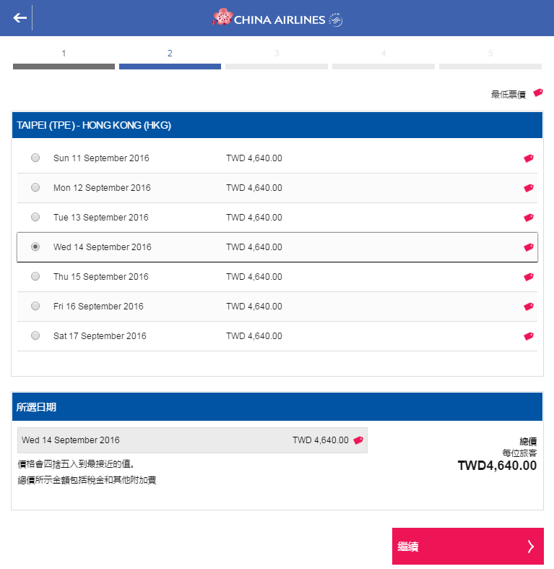

* + 1. WSDL (Web Service Description Language)

[Provide WSDL for SOAP service]

* 1. Errors
     1. Errors XML

[Show example error XML]

* + 1. Error Messages

| **Error Message Code** | **Error Message Description** |
| --- | --- |
| 991 | Please check required fields. |
| 992 | System maintenance , please try again later , thank you. |